23CSE111

OBJECT ORIENTED PROGRAMMING

LAB MANUAL



**Department of Computer Science and Engineering Amrita School of computing**

**Amrita Vishwa Vidyapeetham, Amaravati Campus**

# Name:T. Sri Harshith

**Verified By: Roll No: AV.SC.U4CSE243335**

|  |  |  |  |  |
| --- | --- | --- | --- | --- |
| **S.No.** | **Experiment Name** | **Page No.** | **Remarks** | **Signature** |
| **1** | **Installation Process of JDK** | **3** |  |  |
| **2** | **Simple Java Program for printing basic details of student** | **6** |  |  |
|  |  |  |  |  |
|  |  |  |  |  |
|  |  |  |  |  |
|  |  |  |  |  |
|  |  |  |  |  |

Object Oriented Program

* Open “Oracle” in your web browser.
* Click on “ download Java” in the oracle interface.
* Select the version you want to download (version JDK21 is best).
* Select the Operating System(OS) of your PC and click on the link “x64 installer” to download .
* **Installation:**

**Click on next**

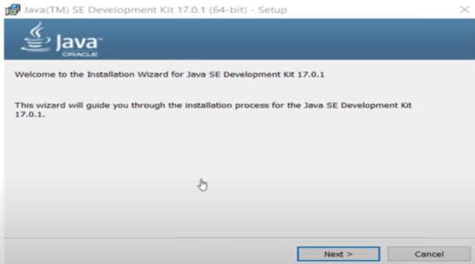

**click on next**

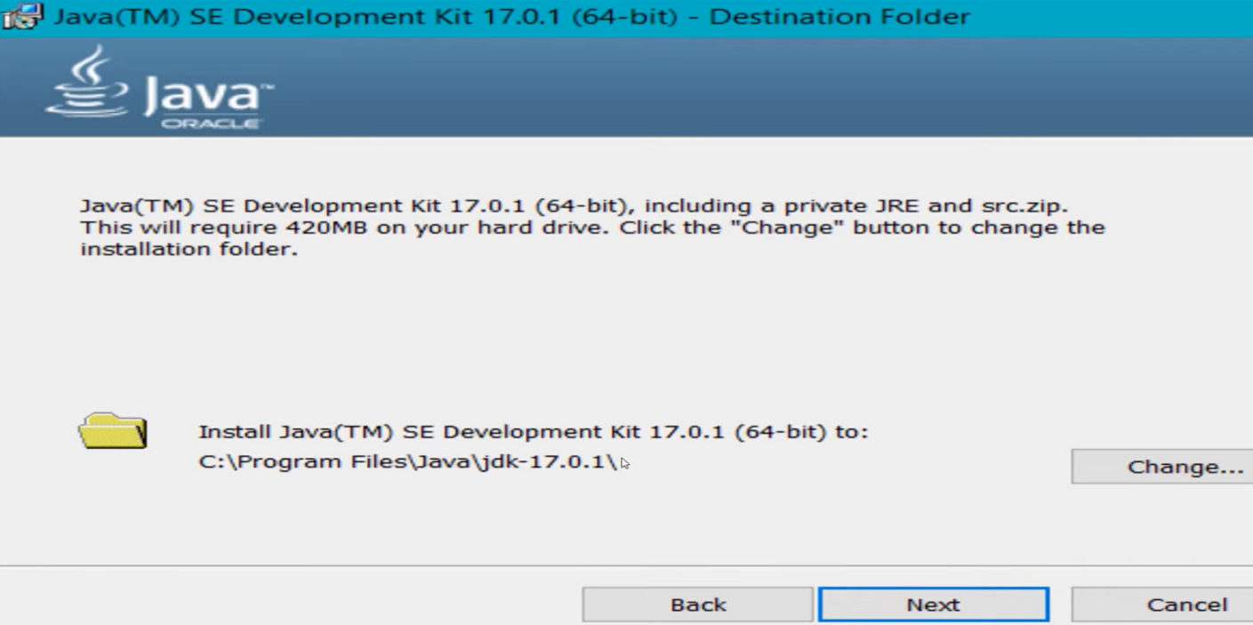

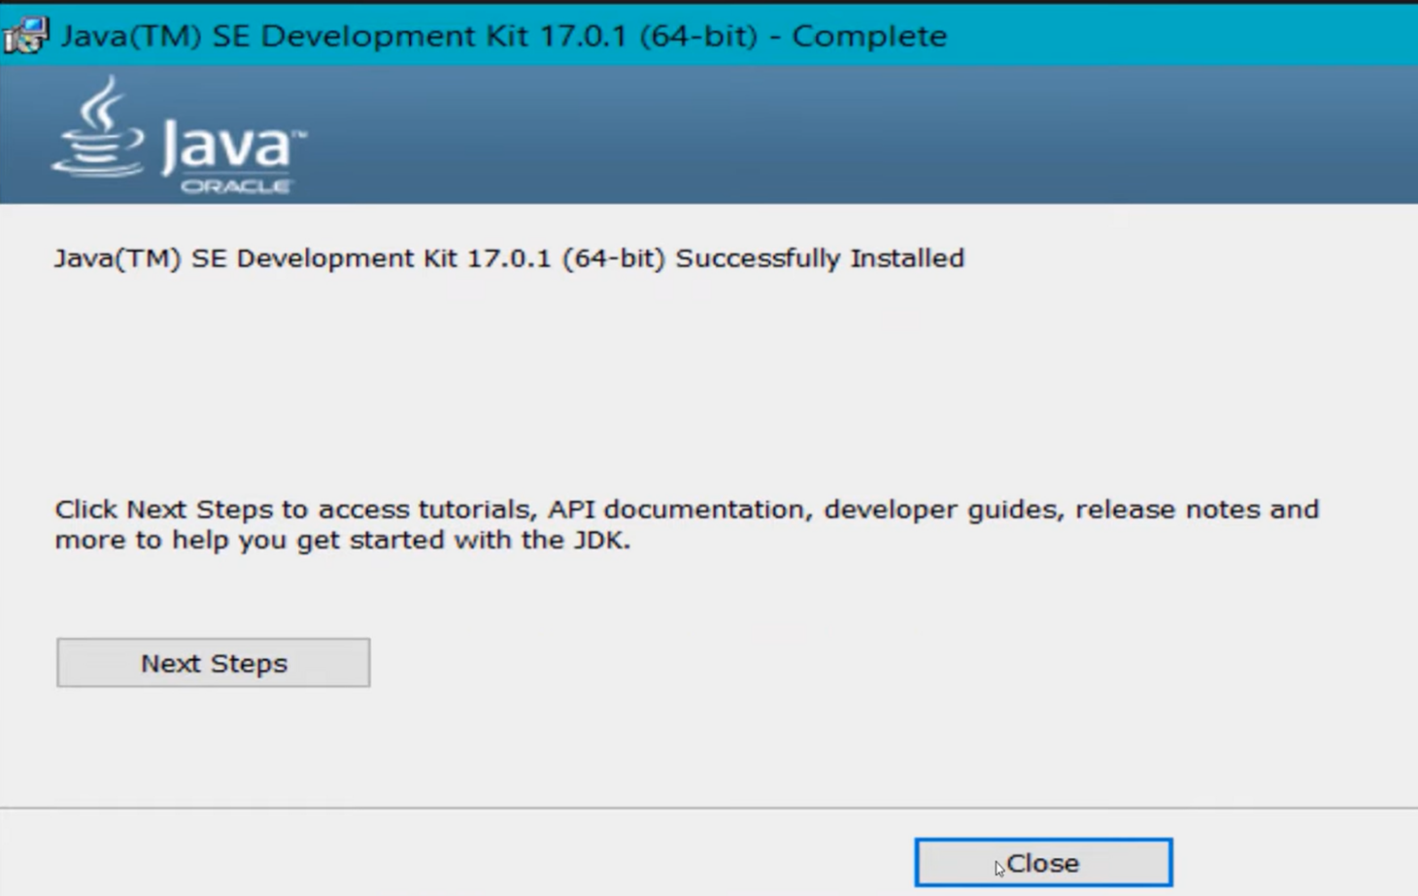**click on close**

* **to check whether java is downloaded correctly or not**
* 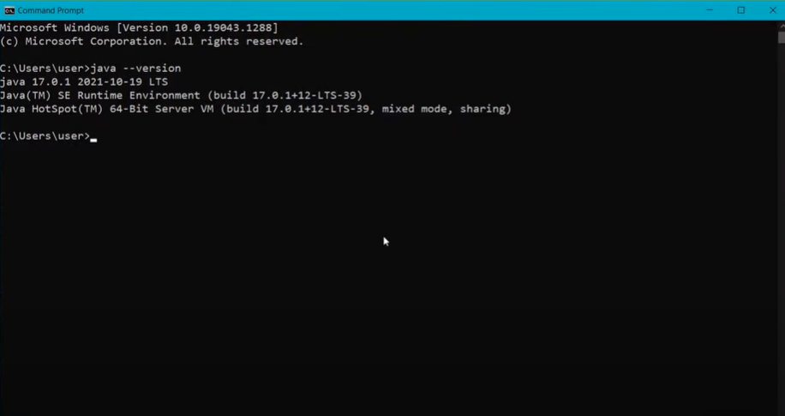**open command window and type “java --version”**
* **to set the path:**
* **Go to “start” and se “Edit the search environment variables”**

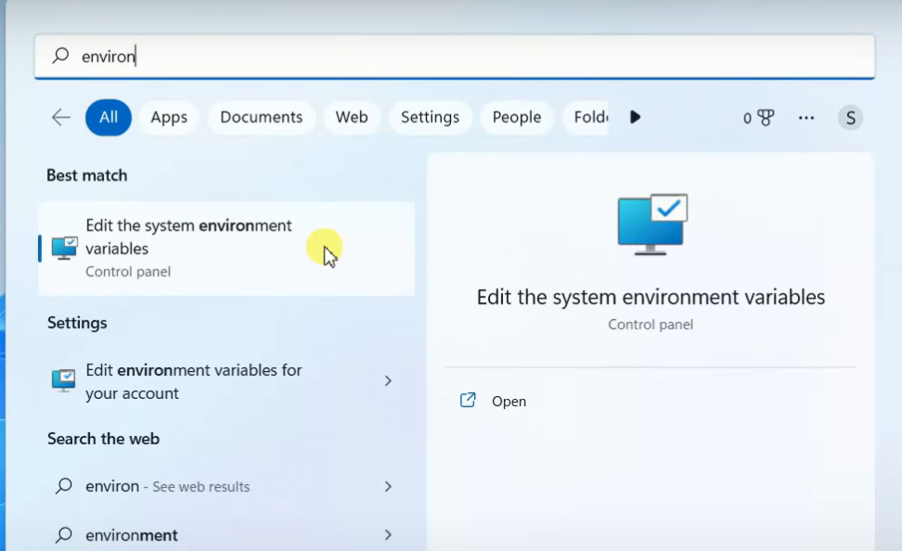

* **Click on open and continue to click on Environment variables**

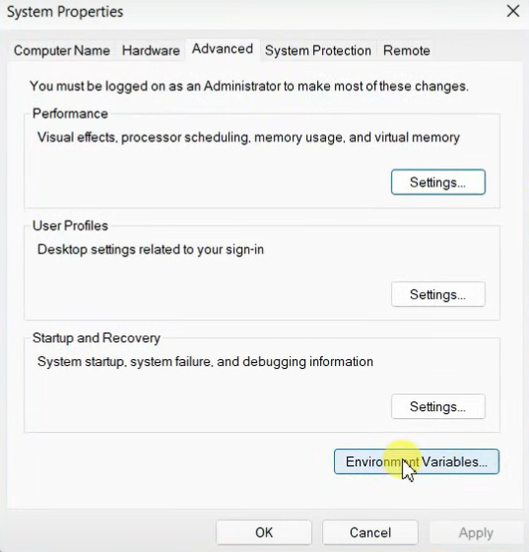

* **Select the “path” option in “system variables”**

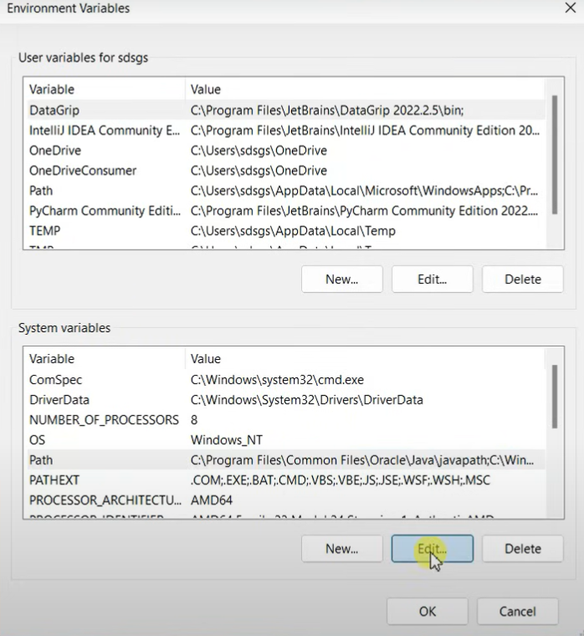

* **Now click on new paste the path of java**

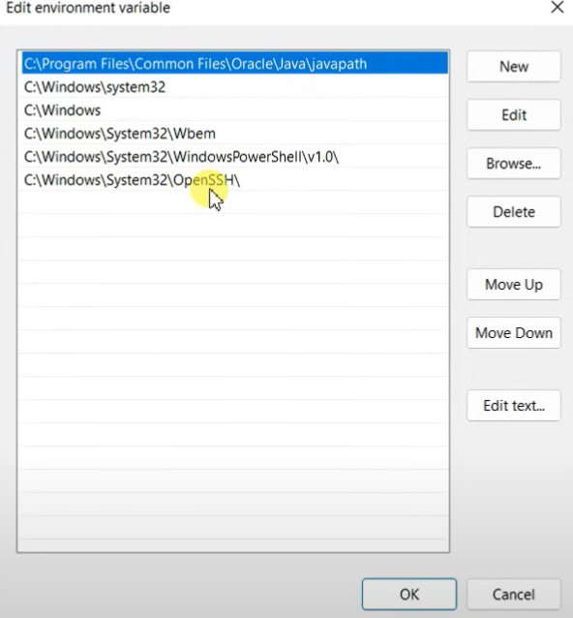

* **To check whether the path is properly set or not**

**Open command window and type “javac --version”**

**If it is showing the exact version of java you are installed then the path is set properly.**

* **Now create a text document with “.java” extension and open in notepad ,**

**To write code.**

**a ) write a simple java program to print your name,roll no,sec etc.**

**Program :**

**class ME**

**{**

**public static void main(String[] args)**

**{**

**System.out.println("NAME= T.Sri Harsith");**

**System.out.println("ROLL NO= AV.SC.U4CSE24335");**

**System.out.println("SEC= B");**

**System.out.println("BRANCH= CSE");**

**}**

**}**

